Five days International Workshop

On

Information Management Tools for Academic and Research Libraries
18 to 22nd December 2017

Brief Workshop Report

Organized by

Central Library
All India Shri Shivaji Memorial Society’s
College of Engineering, Pune-1
Maharashtra (India)

The International workshop on the theme "Information Management Tools for Academic and Research Libraries" was organized by Central Library, AISSMS College of Engineering, Pune-1, Maharashtra, between 18 to 22nd December 2017.There were over 35registered participants around the country. This being the International workshop, the organizers have invited participants from wide spectrum of professionals involved in Library and Information Technology area from the different parts of the country. There were overwhelming response and restricted to 35 delegates only. As a rapporteur had a very daunting task to prepare brief report of each session.

The Inaugural Function:

The International workshop began with introduction and warm welcoming the dignitaries on the dais, off the dais by a team of organizing committee. The Inauguration of International workshop began with lighting the lamp by the dignitaries and offered Pushpanjali to the divine soul of Shri. Chhatrapati Shivaji Maharaj was one of the bravest, most progressive and sensible ruler of India.
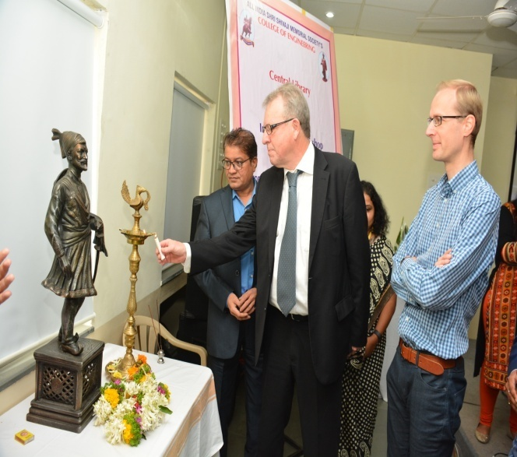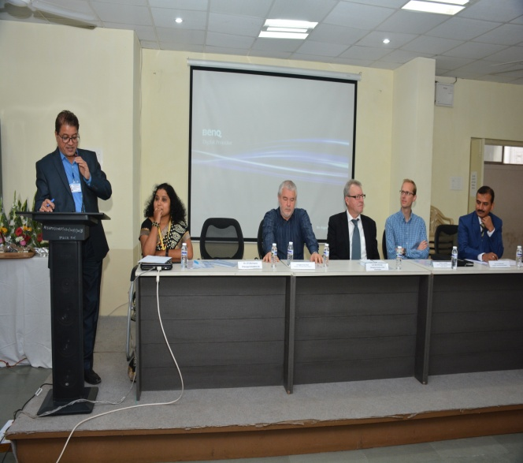
Inaugural function lighting the lamp Dr Bormane(Principal AISSMS) specking at
By Lars Bjørnshauge Inaugural function
Mrs. VrushaliDandawate,Organizing Secretary provided overview of the International workshop and justified the relevance of the theme and contents are required in the present knowledge arena. And then she introduced the guests of honor of inaugural program.
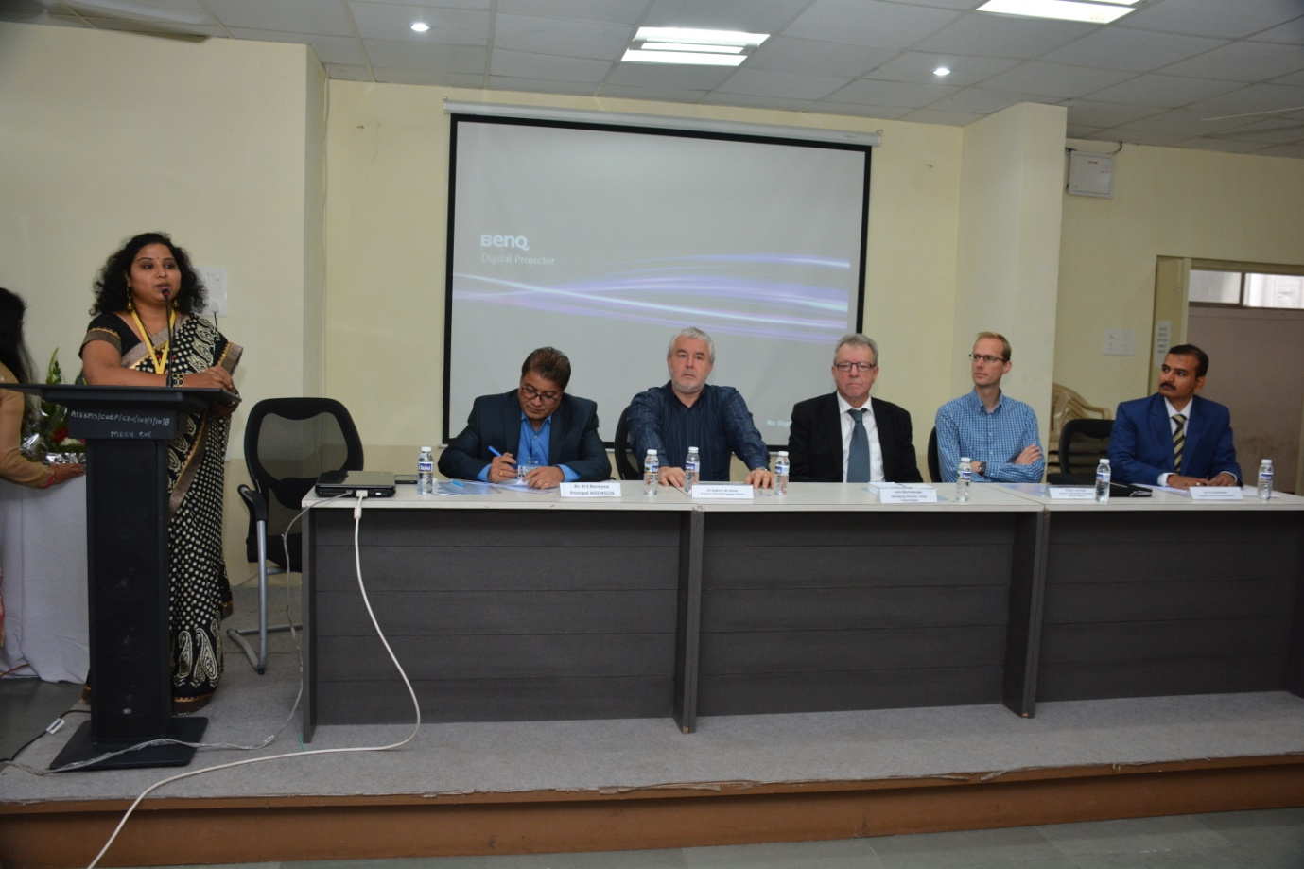
Vrushali Dandawate (Librarian AISSMS) introduced theme of workshop
Dr. D.S.Bormane, Principal, AISSMS, Pune, welcomed the guest and introduced Ms. Vrushali Dandwate as Ambassador and of college Librarian with whole heartedly. He said All India Shri Shivaji Meomrial Society, established as early as in 1917, is a premier educational institution in Pune. Ours is a result oriented Society dedicated to the noble cause of Military, General, Technical & Management Education in India. Further said the roles of the librarian activities are changed in the present era, it is not only lending and receive the books but apart from one has to inculcate Information communication technology to render the better library services to the user community.

Mr. Lars Bjørnshauge Managing Director of DOAJ said that Open source are very popular in developing countries, particularly researchers are producing new knowledge to the open source, which helps to change the global approach. Every institute cannot buy the costly databases like Scopus, Web of Science etc.

Prof. Dr. Egbert de SmetSaid the Pune is educational hub to learn so many courses and very peaceful city. Open source software and technical tools helps to develop the library in modern line. It helps to overcome from traditional practices.
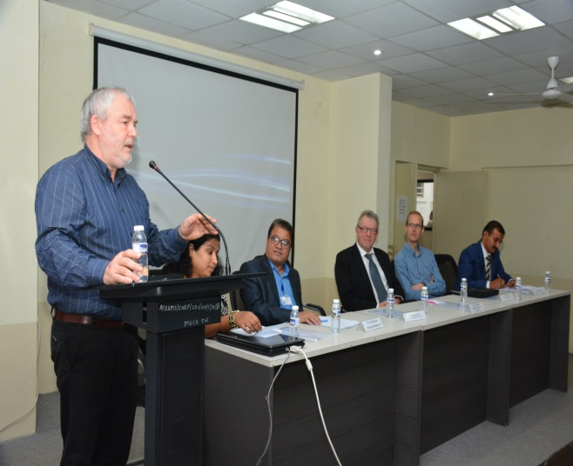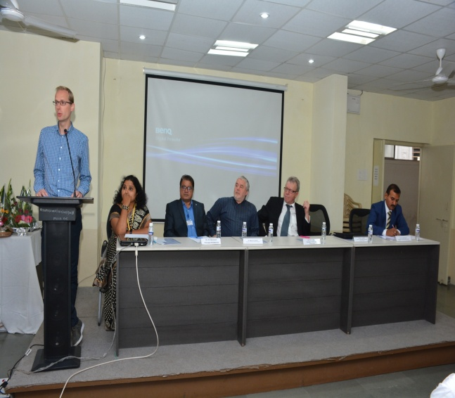
Dr Egbert De Smet (Prof University of Antwerp) and Pieter Lerrnout ( Librarian Hasselt Univerity Belgium) specking at Inaugural function

Mr.PieterLearnout, Head Librarian, Bibliotheek University, Belgium expressed his views that this kind of collaboration event helps to learn the new things. It generates idea to learn and implement in the present work area. Library services can be improved by adopting new tools and services time to time. ICT helps to learn many more things it provides opportunity to learn at national and International level workshop.

After the dignitaries speech concluded with vote of thanks by Ms.Poorvi.

Day one first Technical session begin with Key note address delivered by Mr, Lars, DOAJ, Managing Director,in his keynote address explored how effectively and efficiently OA is functioning, open access has big role to play by adding e-journals e-books and monographs etc. Further explored the public funded research should be accessible to all without any restrictions. Need to be shared and protect the traditional knowledge model scholarly, libraries can potentially provide information free to all for reading, re-use and re-mix etc. Further, explained the types of Open access available like Green, Gold and Hybrid. Stop blaming the publishers “Instead of being gate keepers publishing unauthorized users accessing publically funded research”. He shared more detail about DOAJ its editorial board functionality and accepting quality peer reviewed journals, its purely non-profit oriented company. After presentation interacted with participant had question and answer session.
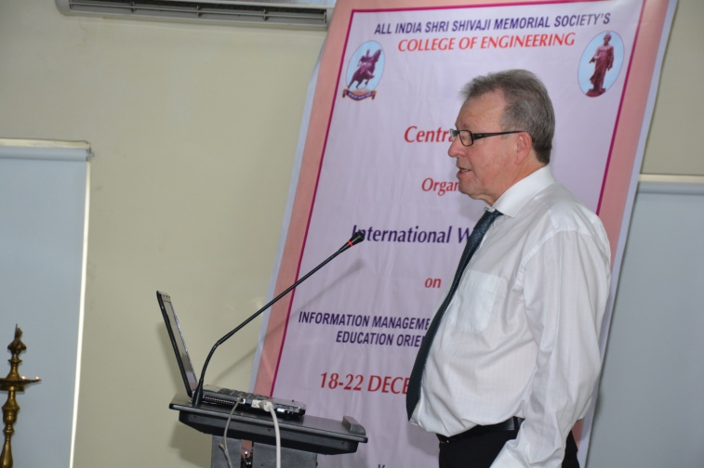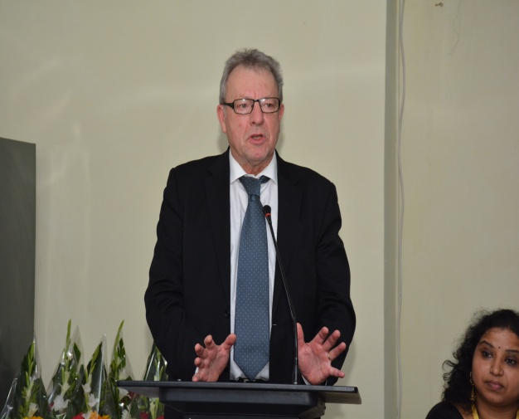
Key Note address given by Lars
Second Technical session ignited speaker Mr. Kishore Ingale, Head Pune Information Resource centre, Tata Consultancy services was touched up on Applying creative common for your work with copy right issues like share were, free were, creative common, general public license and copy left.

After lunch break the third technical session begin with invited talk from Prof.Dr. Egbert De smet,on Libraries and information automation with a Swiss Knif: ABCD. Explained about E-grannary, Libhub, DOAJ, DOAR, Proquest and Cloud system functions. In detailed discussion explained about cataloguing, OPAC acquisition module, Serials etc.

Organising secretory requested all participant to introduced one by one to know there background from which institution they are coming from, further to know there expectation from workshop etc.

Product demonstration from SLIM 21 system for library information management. Explained about many institutions are already using this software at corporate, academic, defense, banks, public and state library etc. had question and answer session.

Vrushali Dandawate Librarian AISSMS COE started DCLA ( Developing country Library Association ) She gave brief presentation about theme and need of such association. The registration of this association will be free and more details will be share by her after website creation of DCLA. https://www.slideshare.net/vrushalibasarkar/developing-country-library-association-dcla?qid=19d99684-ba44-4270-937a-a540693711b3&v=&b=&from_search=2
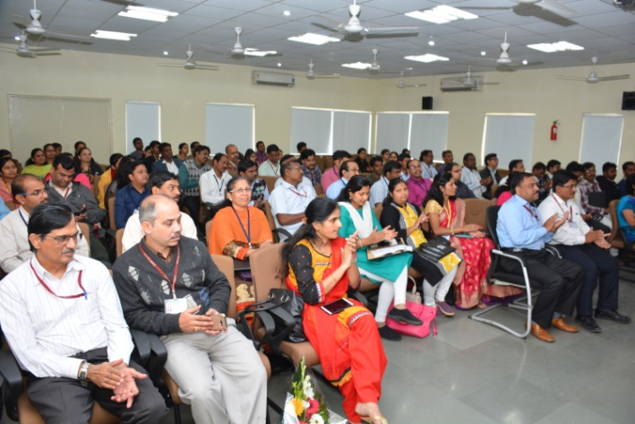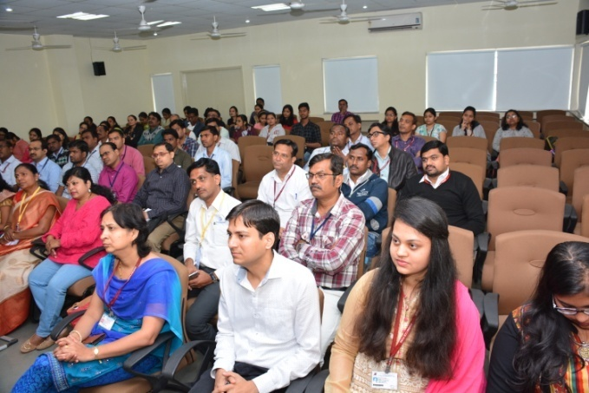
Participant for Workshop
Second Day of technical session begin on time; 19/12/2017
Dr.Samir Kumar Jalal, Deputy Librarian, IIT Kharagpur gave a invited talk on Bibliometric to Altmetrics: Tool and Techniques and Indicators. Explained about bibliometric, cyber metric, webometrics, informatics and scientometrics. He added the types of law involved to test the data like Broadford law, Lotkas law and zipf’s law various test analysis learnt through the class. Followed by the question and answer session.
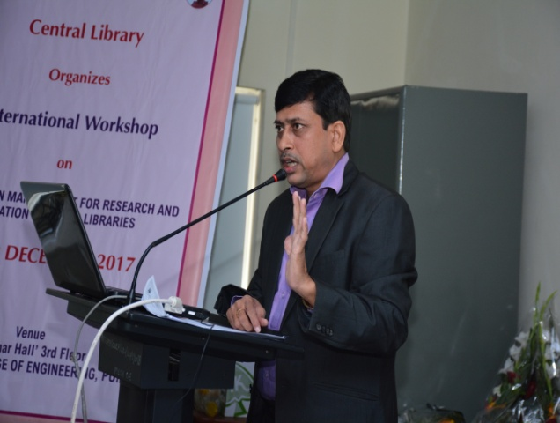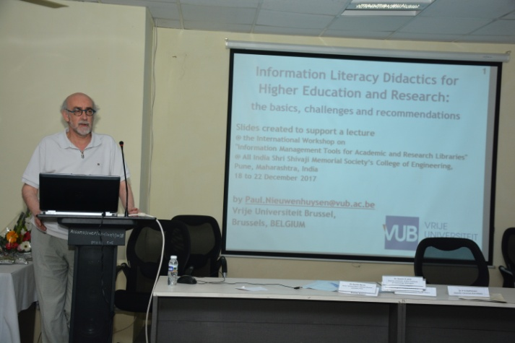
Dr Samir Jalal ( IIT Khragpur)Giving lecture Prof Paul Nieuwenhuysen talking on
on Bibliometrics image searches
Mr.Lars gave a talk on Research assessment, questionable publishers, whitelists and improving the quality of Indian Journals. The topic was very relevant to the Indian context and how to merge the Indian journals in to DOAJ was the serious debate. The Research assessment system has to change based on journals impact factor. The information should be shared in open access. Further, he highlighted about unethical publisher practice and quoted some examples.

Prof. Paul N, gave a talk on Information Literacy Didactics for higher education and Research: The basics challenges and recommendations. He gave brief introduction about him and explained about information literacy was lifelong learning to common to all discipline to increase level of information literacy by accessing the needed information effectively and efficiently. He made certain recommendation that present digital environment has increased its competencies in area of information literacy like digital literacy, media literacy, meta literacy, computer literacy and information literacy is big challenge to adopt it. Had question and answer session after the presentation.

After the lunch session Dr. Egbert de Smet delivered talk on ABCD software installation. He gave step to install the software with hands on experience covering the automation software and its modules like acquisition, cataloguing, OPAC, report, information services, Library website, e-books, repository, e-discovery with meta search engine and create and manage your own database. UNESCO published open source software. Its compatible to access any browser like Mozilla or internet explorer. In detailed he explained about Apache server, webserver running tools and metadata harvesting.
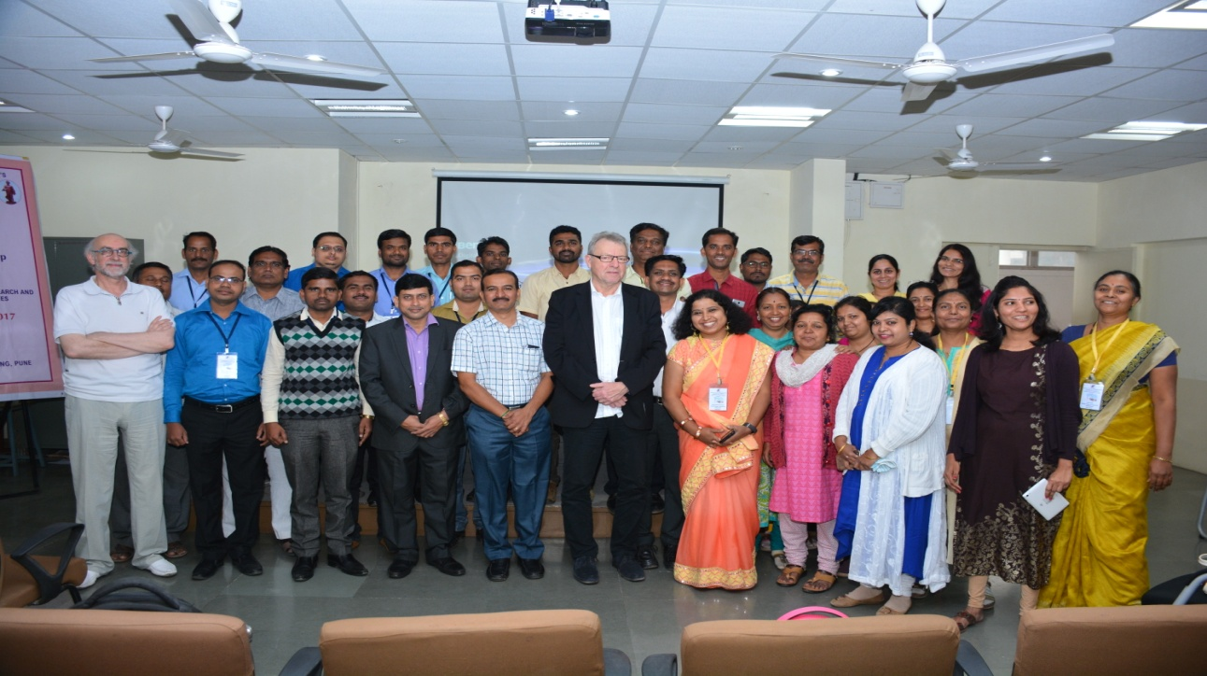
Participants librarians

Third Day session 20/12/2017
Invited talk from Mr. Pieter Learnout on Introduction setting up a library website with Wordpress. In the introduction he covered why library website is required and its importance to design the website. The website should provide scientific information by offering overview of the library and its services. He explained Lesson 1,2 and 3 to understand the concept very clearly by the participants. Always website should have discovery tool and general search tool. Frequently asked question helps to navigate the users, he added multiple language helps to build the website in different language.
He explained about open source software Wordpress, which is world most popular tool to create the website, blogs and discussed about the advantages and disadvantages etc.

Third day of second technical session talk delivered by Dr. Samir Kumar Jalal, Deputy Librarian, IIT Kharagpur on Analysis of Research output using open source software Bibexcel and publish or perish(POP). Hands on experience with various tools like SCIMAT, Bibexcel, Citespace-II, Science of Science, Histcite, Vosviewes, Ucinet, Pajek, NodelXL Network overview discovery and exploration for excel. It was wonderful experience handling each tool to test and see the result of h-index, i-index and g-index etc.
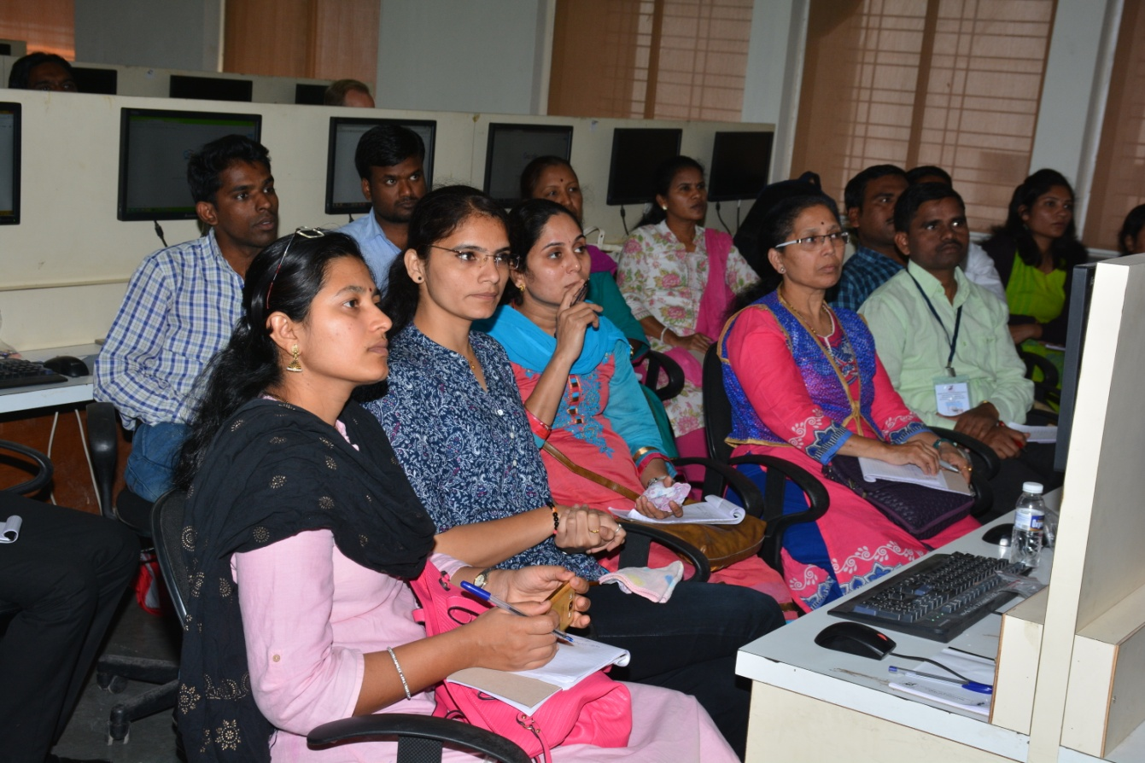
Practical Sessions by Dr Samir Jalal and Pieter Lernout

After the Lunch break another hands on experience session begin with Mr. Pieter Lernout on setting up a library website with Wordpress. He was determined to train each one to host library webpage by individual or library website. Very interesting hands on experience learned with personality by installing WAMP or XAMPP one after another. All participants are excited to design the website and learned the skills, it was very user friendly class each one of the participant experienced and learned the website designing and hosting.
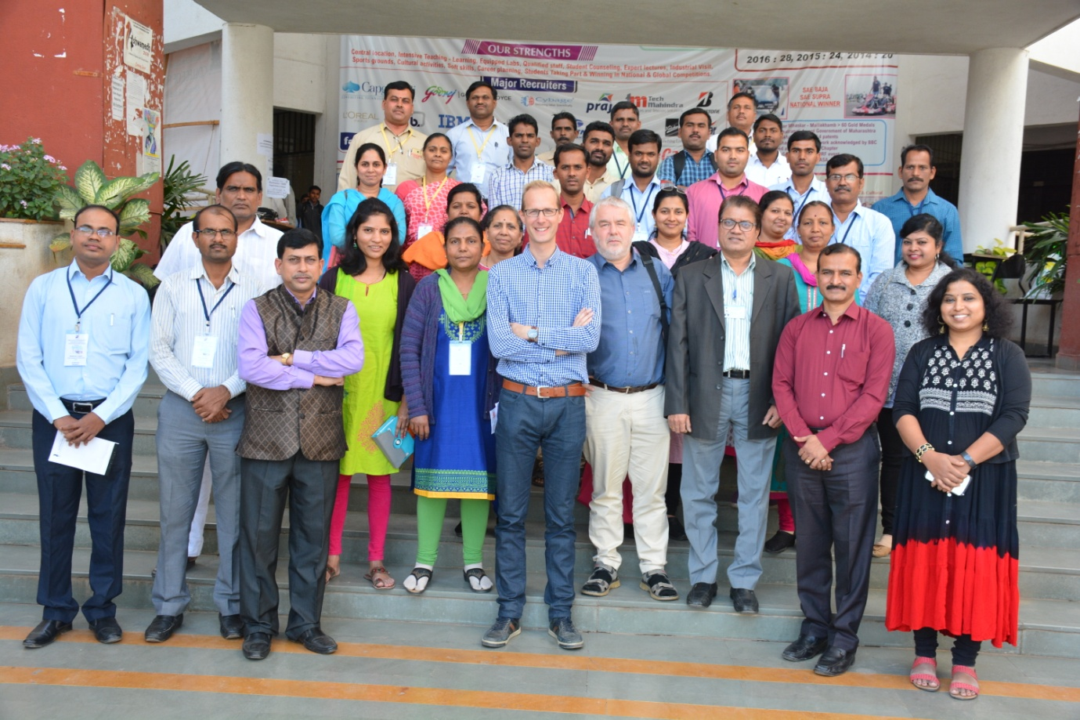
Participants Librarian with Principal Sir and International Experts
Forth Day technical session
Prof. Paul N gave a invited talk on Image information discovery a tutorial workshop. Explained about how the images are searched through google and searching for information using query that includes words and images. He said images are very important as information sources, due to increasing number of digital cameras, all sources of images are open access. Some are useful and some are not useful. Even these images are classified as per search query. Among search engines YAHOO and Bingo are the same and competing with google.

Second session of the day begin with Prof. Paul N. on Search by image to find information that is sematic related to the image. Quoted several examples very nicely original photo sculpture, search with original image used for Book cover etc. explained about copyright infringements, plagiarism etc. Had question and answer session.

After Lunch Dr. Egbert de Smet, taken a practical session hands on experience to install Automation software ABCD. It was new experience each participant operated individually and learnt the install of automation software. Had question and answer session.
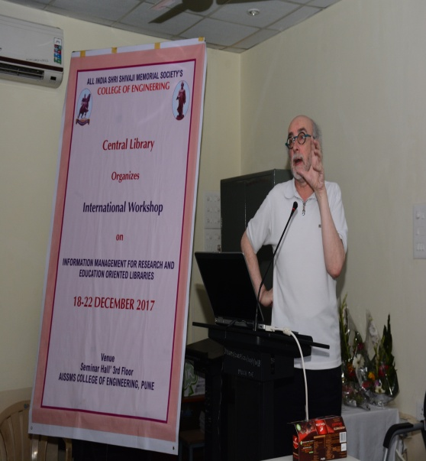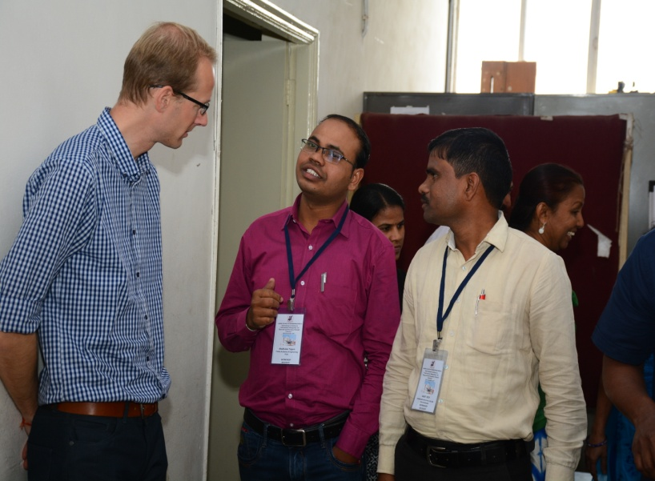
Technical Sessions by Prof Paul and Piter Lernout
5th Day session begin with Dr. SunitaBarve, Sr.Technical Officer, KRC/Library, CSIR-NCL, Puneon DSPACE: Institutional repository tool. Explained in detail how this open software Dspace helps to create the each institution repository in general. It was quite interesting to learn in depth of open source software by creating the communities and sub-community to uploading the data, and retrieve the data in single platform. The building up institutional repository varies from one institution to another institution.
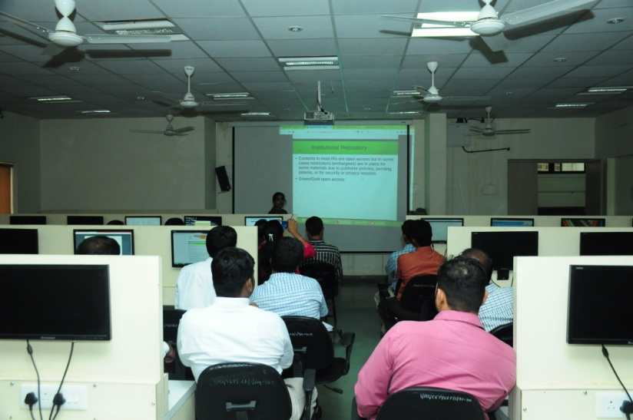
Technical Session by Sunita Barve ( NCL Pune)

After five days International Workshop, Panel Discussions were held on the various burning issues of Libraries.

It was resolved to have a model library should have Open Access tools for library and each librarian should learn to develop the library as it is available in freely. The panel members strongly felt that, the Central Library,AISSMS has already developed open source concept in the library and hence, this serve as nodal centre to the other library.

Valedictory address and Certification distribution

After this, Valedictory program began with a Rapporteur’s report by Dr. P.S. Kattimani who briefed about the gist of the 5 days International workshop and deliberations held to the dignitaries and the participants. Very positive feedback from the participants and all of them appreciated the success of workshop and arrangements made during these 5 days and congratulated the organizing secretary and team.
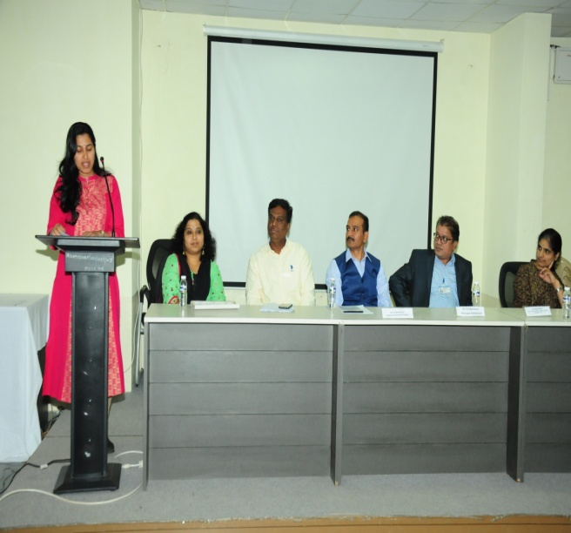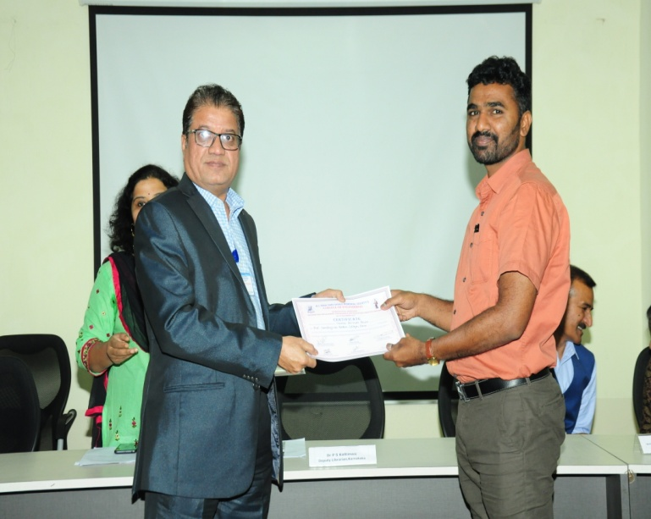
Participant Feedback Certificate Distribution

Dr. P.S. Kattimani Vrushali S. Dandawate
Rapporteur General Organizing Secretary

